- Big Map

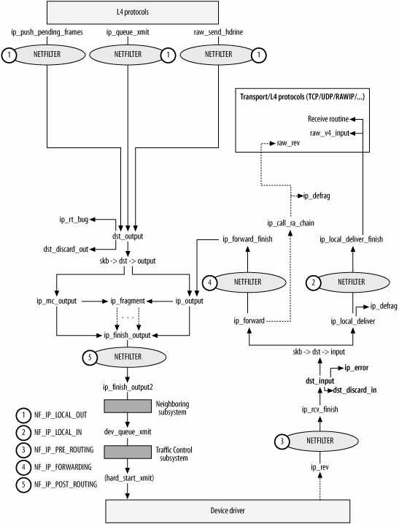

- IP layer initialization

static struct list_head ptype_base[PTYPE_HASH_SIZE] __read_mostly;
static struct list_head ptype_all __read_mostly; /* Taps */
L3 receive packet handler: dev_add_pack() put the L3 receive packet handler to the ptype_all or ptype_base list

struct packet_type {
__be16 type; /* This is really htons(ether_type). */
struct net_device *dev; /* NULL is wildcarded here */
int (*func) (struct sk_buff *, struct net_device *, struct packet_type *, struct net_device *);
...........
};

static struct packet_type ip_packet_type __read_mostly = {
.type = cpu_to_be16(ETH_P_IP),
.func = ip_rcv, /* get packet from deliver_skb in L2 in ptype_base[ETH_P_IP]*/
…………….
};

static const struct net_protocol tcp_protocol = {
.early_demux = tcp_v4_early_demux,
.handler = tcp_v4_rcv,
.err_handler = tcp_v4_err,
.gso_send_check = tcp_v4_gso_send_check,
.gso_segment = tcp_tso_segment,
.gro_receive = tcp4_gro_receive,
.gro_complete = tcp4_gro_complete,
.no_policy = 1,
.netns_ok = 1,
};

static const struct net_protocol udp_protocol = {
.handler = udp_rcv,
.err_handler = udp_err,
.gso_send_check = udp4_ufo_send_check,
.gso_segment = udp4_ufo_fragment,
.no_policy = 1,
.netns_ok = 1,
};

int inet_init(void)
{
……………
1) init the ip module
ip_init();
2) add L4 protocol hander, deliver to L4 hander
if (inet_add_protocol(&udp_protocol, IPPROTO_UDP) < 0)
pr_crit("%s: Cannot add UDP protocol\n", __func__);
if (inet_add_protocol(&tcp_protocol, IPPROTO_TCP) < 0)
pr_crit("%s: Cannot add TCP protocol\n", __func__);
3) register ip recv hander(ip_recv) from data link layer deliver_skb
dev_add_pack(&ip_packet_type);
}

- IP receive

int ip_rcv()
{
1) drop all the other packet When the interface is in promisc
if (skb->pkt_type == PACKET_OTHERHOST)
goto drop;
- if it is shared just clone so we can modify the skb packet
skb = skb_share_check(skb, GFP_ATOMIC));
- check length
if (iph->ihl < 5 || iph->version != 4)
goto inhdr_error;
if (!pskb_may_pull(skb, iph->ihl*4))
goto inhdr_errorcheck length
- IP checksum
if (unlikely(ip_fast_csum((u8 *)iph, iph->ihl)))
goto inhdr_error
- NF_INET_PRE_ROUTING filter 3 and goto ip_rcv_finish
return NF_HOOK(NFPROTO_IPV4, NF_INET_PRE_ROUTING, skb, dev, NULL, ip_rcv_finish);
}

int ip_rcv_finish()
{
1) handle options
if (iph->ihl > 5 && ip_rcv_options(skb))
goto drop;
2) route the skb through route-table
if (!skb_dst(skb)) //TODO: There is dst for all the packet or not
{ /*if there is no dst just search
int err = ip_route_input_noref(skb, iph->daddr, iph->saddr, iph->tos, skb->dev);
a. local packet:
skb_dst(skb)->input(skb) = ip_local_deliver;
skb_dst(skb)->output(skb) = ip_rt_bug;//never output
b. non-local packet:
skb_dst(skb)->input(skb) = ip_forward; //TODO
skb_dst(skb)->output(skb) = ip_output;
}
rt = skb_rtable(skb);
return skb_dst(skb)->input(skb);
}
int ip_route_input_noref(struct sk_buff *skb, __be32 daddr, __be32 saddr, u8 tos, struct net_device *dev)
{
res = ip_route_input_slow(skb, daddr, saddr, tos, dev);
}
static int ip_route_input_slow(struct sk_buff *skb, __be32 daddr, __be32 saddr, u8 tos, struct net_device *dev)
{
/* IP on this device is disabled. */
if (!in_dev)
goto out;
/*src ip can't be multicast and broadcast ip*/
if (ipv4_is_multicast(saddr) || ipv4_is_lbcast(saddr))
goto martian_source;

/*both src and dst ip can't be zeronet */
if (ipv4_is_zeronet(saddr))
goto martian_source;
if (ipv4_is_zeronet(daddr))
goto martian_destination;
fl4.flowi4_oif = 0;
fl4.flowi4_iif = oif;
fl4.daddr = dst;
fl4.saddr = src;
fl4.flowi4_tos = tos;
fl4.flowi4_scope = RT_SCOPE_UNIVERSE;

/* route search*/
/*if the dst ip is one of the local ip, res.type is RTN_LOCAL*/
err = fib_lookup(net, &fl4, &res); //TODO how to work
if (err != 0)
goto no_route;
if (res.type == RTN_LOCAL) {
/*src ip check */
err = fib_validate_source(skb, saddr, daddr, tos, LOOPBACK_IFINDEX, dev, in_dev, &itag);
if (err < 0)
goto martian_source_keep_err;
goto local_input;
}
no_route:
res.type = RTN_UNREACHABLE;
local_input:
rth = rt_dst_alloc(net->loopback_dev,IN_DEV_CONF_GET(in_dev, NOPOLICY), false, do_cache);
if (!rth)
goto e_nobufs;
/*set input callback*/
rth->dst.input= ip_local_deliver;
rth->dst.output= ip_rt_bug;
rth->rt_flags = flags|RTCF_LOCAL
if (res.type == RTN_UNREACHABLE) {
rth->dst.input= ip_error;
rth->dst.error= -err;
rth->rt_flags &= ~RTCF_LOCAL;
}
/*set rtable to skb->_skb_refdst*/
skb_dst_set(skb, &rth->dst);
}

/* the src ip is not one of the local ip address*/
when enable RP_FILTER, the device receive the packet should equal the route device that send a packet which dst ip is the
src ip of the received packet*/
int fib_validate_source()
{
int r = IN_DEV_RPFILTER(idev);/*RP_FILTER of all and ethx*/
/*route search reverse*/
fl4.flowi4_oif = 0;
fl4.flowi4_iif = oif;
fl4.daddr = src;
fl4.saddr = dst;
fl4.flowi4_tos = tos;
fl4.flowi4_scope = RT_SCOPE_UNIVERSE;
if (fib_lookup(net, &fl4, &res))
goto last_resort;
dev_match = false;
if (FIB_RES_DEV(res) == dev)
dev_match = true;

if (dev_match) {
ret = FIB_RES_NH(res).nh_scope >= RT_SCOPE_HOST;
return ret;
}
last_resort:
if (rpf)
goto e_rpf;
return 0;
e_rpf:
return -EXDEV;
}
example:
server has two network card eth0 and eth1 with mac address MAC1 and MAC2, ip address 192.168.60.7 and 192.168.1.7
send a packet on server2 in the same LAN using AF_packet raw socket. the packet dstMAC is MAC1, src ip is 192.168.1.5, dst ip 192.168.1.7.
1). default
on server the packet can't be receive for the fib_validate_source. Because sending a packet with dst ip 192.168.1.7 should through eth1 on server, but the packet received from eth0.
2).
echo 0 > /proc/sys/net/ipv4/conf/all/rp_filter
echo 0 > /proc/sys/net/ipv4/conf/eth0/rp_filter
server can receive the packet with disable device validate of fib_validate_source.

a. local packet
int ip_local_deliver()
{
1) defrag the packet for fragment packets
if (ip_is_fragment(ip_hdr(skb))) {
if (ip_defrag(skb, IP_DEFRAG_LOCAL_DELIVER))
return 0;
}
2) NF_INET_LOCAL_IN filter 2
return NF_HOOK(NFPROTO_IPV4, NF_INET_LOCAL_IN, skb, skb->dev, NULL, ip_local_deliver_finish);
}

int ip_local_deliver_finish()
{
- set transport header
__skb_pull(skb, ip_hdrlen(skb));
/* Point into the IP datagram, just past the header. */
skb_reset_transport_header(skb);
- raw socket deliver, deliver to raw anyway
raw_local_deliver(skb, protocol); // raw_v4_input

- get L4 handler through iph->protocol and inet_protos(add in the inet_init)
ipprot = rcu_dereference(inet_protos[protocol]);
ret = ipprot->handler(skb);
- udp handler: udp_rcv
- tcp handler: tcp_v4_rcv
}

b. non-local packet

int ip_forward()
{
- checksum change for forward packet
skb->ip_summed = CHECKSUM_NONE;
2) decrease the ttl
if (ip_hdr(skb)->ttl <= 1)
goto too_many_hops;
ip_decrease_ttl(iph);
3) NF_INET_FORWARD filter 4
return NF_HOOK(NFPROTO_IPV4, NF_INET_FORWARD, skb, skb->dev,
rt->dst.dev, ip_forward_finish);
}

int ip_forward_finish()
{
- handle forward opt
struct ip_options *opt = &(IPCB(skb)->opt);
if (unlikely(opt->optlen))
ip_forward_options(skb);
- dst out the packet: should be ip_output for forward packet in ip_rcv_finish
return skb_dst(skb)->output(skb); /* ip_output()*/
}

- IP send

int ip_make_skb();/*make skb in transport level*/

int ip_send_skb()
{
err = ip_local_out(skb);
}

int ip_local_out()
{
- checksum the skb, but not the fraglists
struct iphdr *iph = ip_hdr(skb);

iph->tot_len = htons(skb->len);
ip_send_check(iph);
- NF_INET_LOCAL_OUT filter 1
/*the dst_output should be ip_output*/
//TODO how to get dst_output
return nf_hook(NFPROTO_IPV4, NF_INET_LOCAL_OUT, skb, NULL,
skb_dst(skb)->dev, dst_output); /* ip_output()*/

}

int ip_output()
{
- set skb->dev and protocol
struct net_device *dev = skb_dst(skb)->dev;
skb->dev = dev;
skb->protocol = htons(ETH_P_IP);
- NF_INET_POST_ROUTING filter 5
return NF_HOOK_COND(NFPROTO_IPV4, NF_INET_POST_ROUTING, skb, NULL, dev, ip_finish_output, !(IPCB(skb)->flags & IPSKB_REROUTED));
}

int int ip_finish_output()
{
/*ip fragment*/
if (skb->len > ip_skb_dst_mtu(skb) && !skb_is_gso(skb))
return ip_fragment(skb, ip_finish_output2);
else
return ip_finish_output2(skb);
}

int ip_finish_output2()
{
- Neighboring system //TODO
- dev_queue_xmit
}

